How to use the civil war fix scripts.

Thank you for reading this tutorial. There are four steps to imbed my scripts.

Tools required: PFM and Excel.

1. Add the *civil_war_fix.lua* and *civil_war_string.lua* from my *civil_war_fix.pack* into your mod pack.

(If your mod is based on grand campaign, add them into main_attila subfolder. If based on the Last Romans, add them into bel_attila subfolder. And if based on Age of Charlemagne, add them into cha_attila subfolder.)

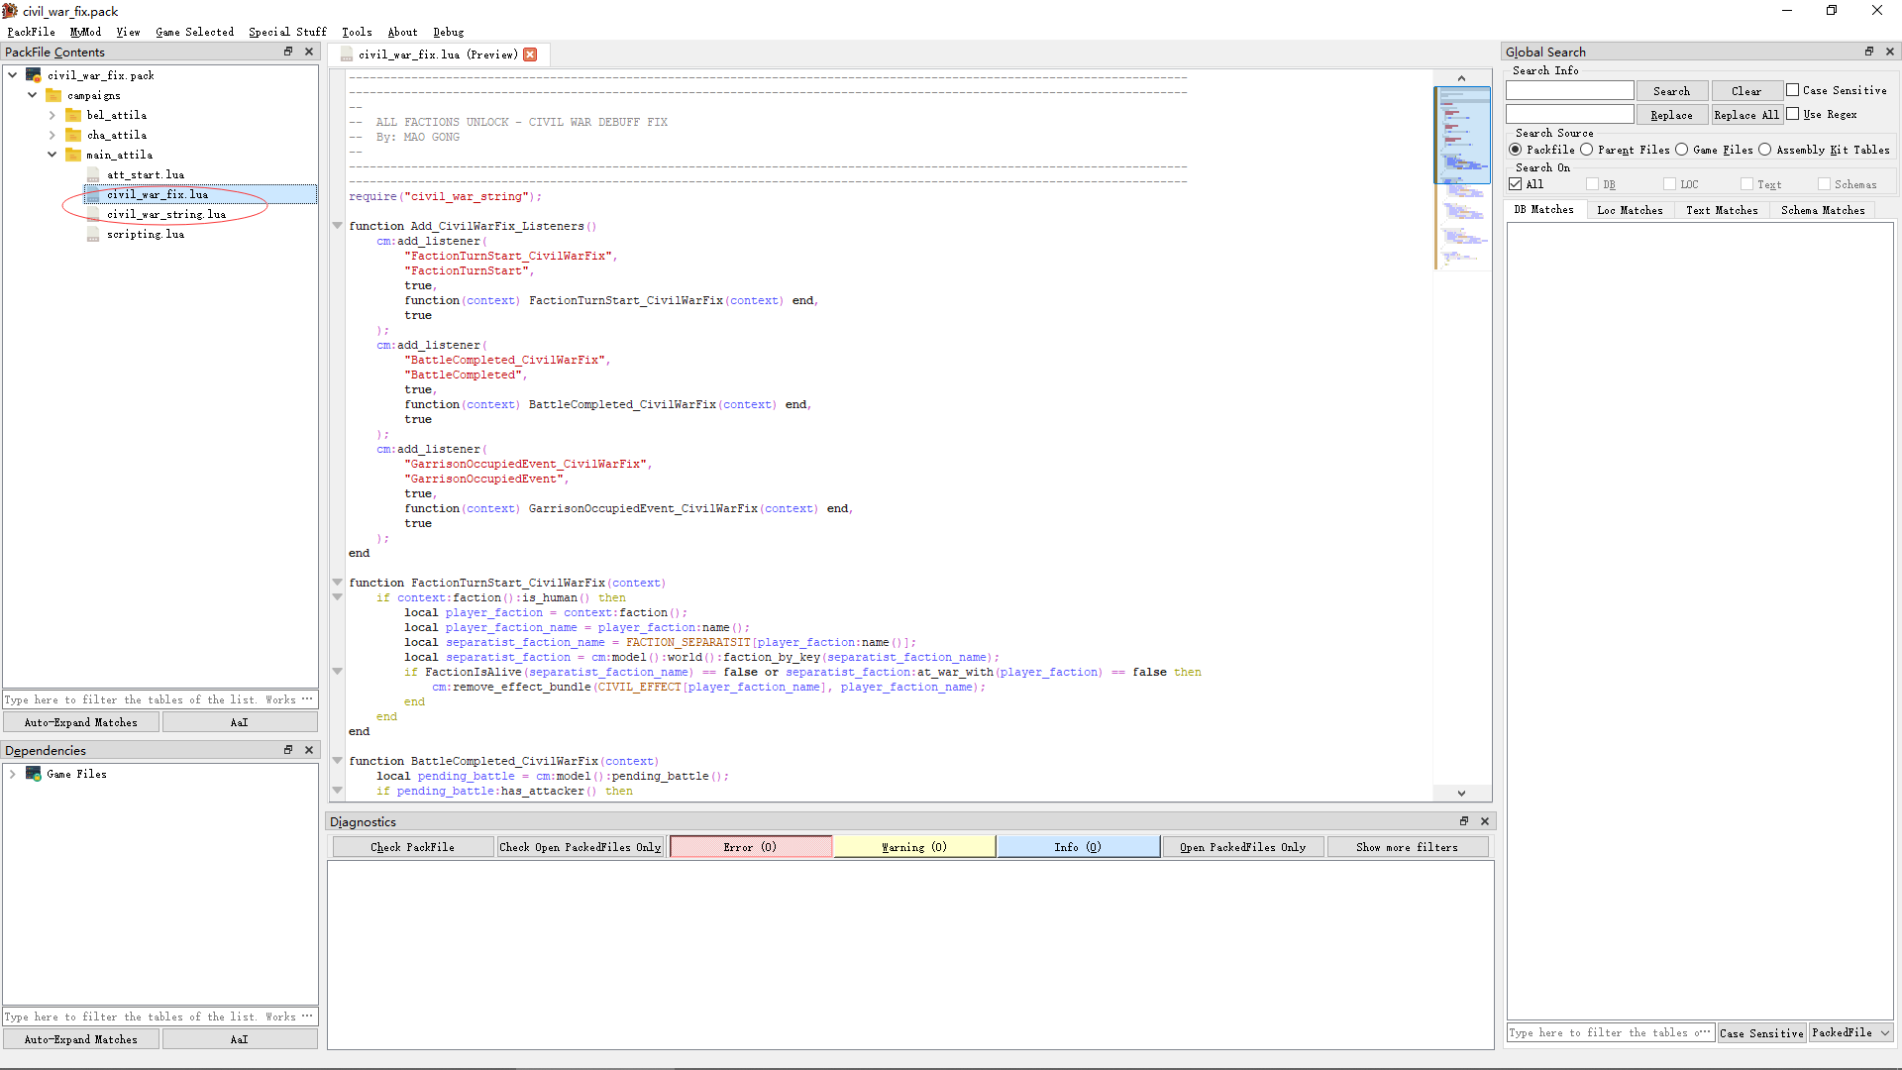

2. If you have edited your *scripting.lua* before, add a line of code in it as follows.

Otherwise, add the *scripting.lua* from my *civil_war_fix.pack* into your mod pack.

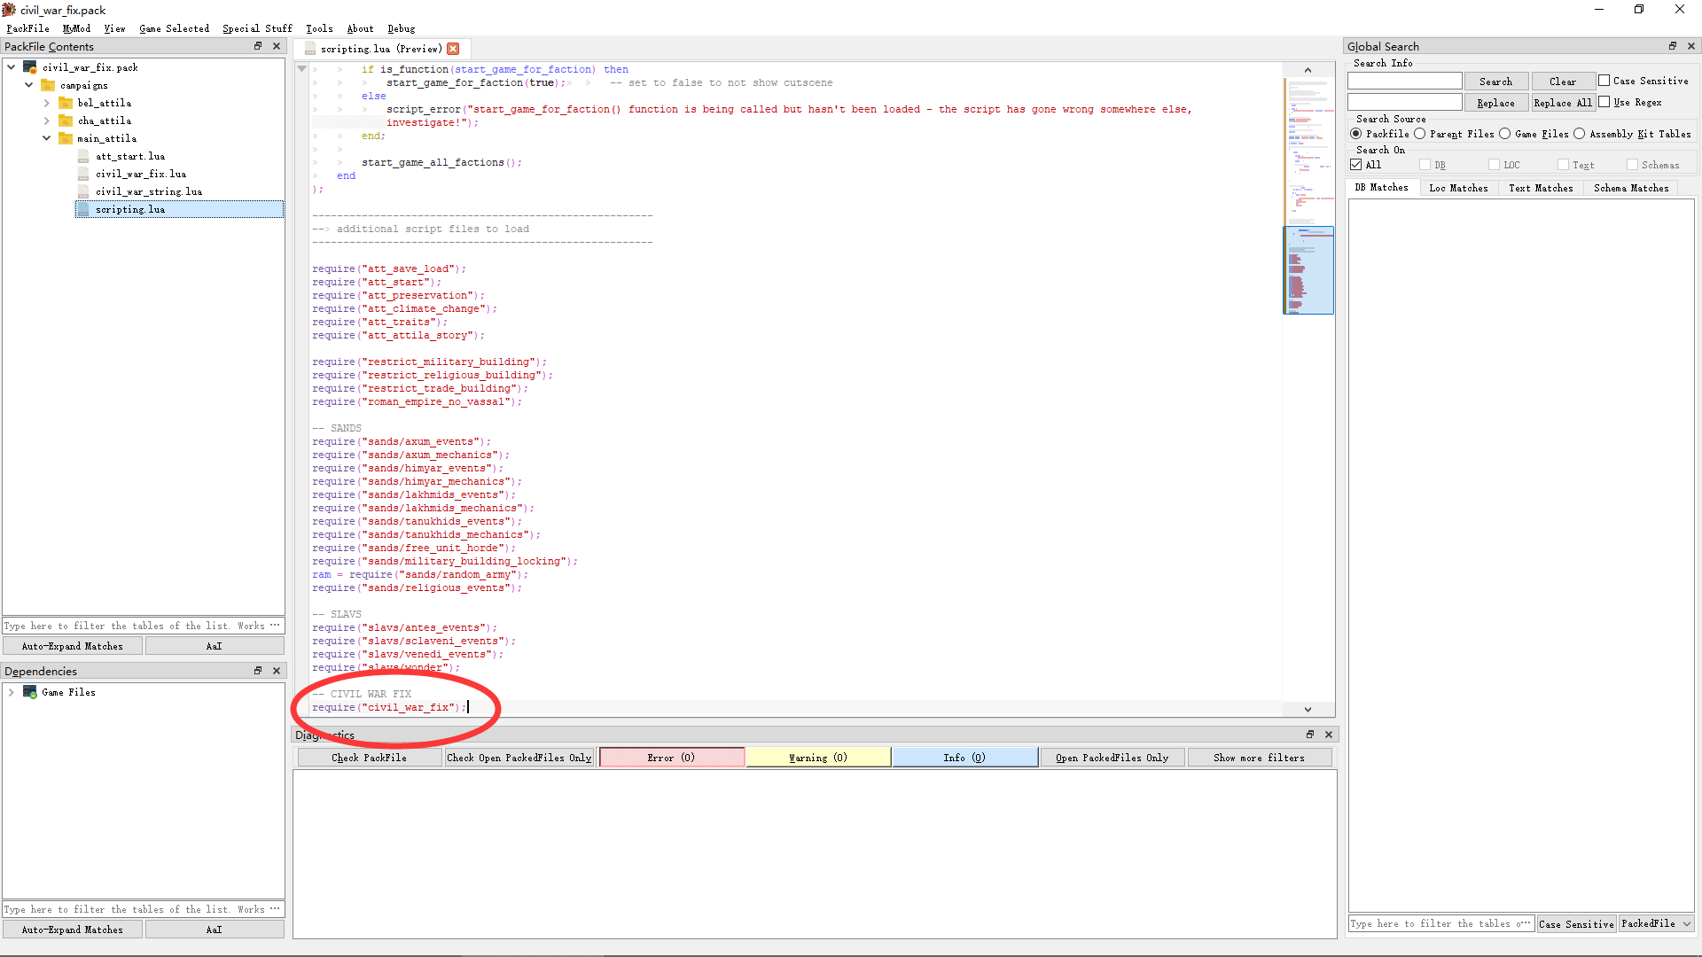

3. If you have edited your *att_start.lua* before, add a line of code in it as follows.

Otherwise, add the *att_start.lua* from my *civil_war_fix.pack* into your mod pack.

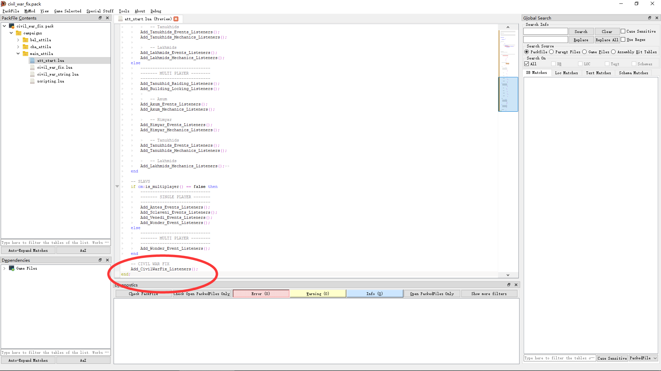

4. If you have edited *db/faction_civil_war_setups_table* before, do as follows. Otherwise, skip step 4.

1) Copy the 3 columns from your *db/faction_civil_war_setups_table* into sheet1/column A, sheet1/column C, sheet2/column A and sheet2/column C in Excel separately as follows.

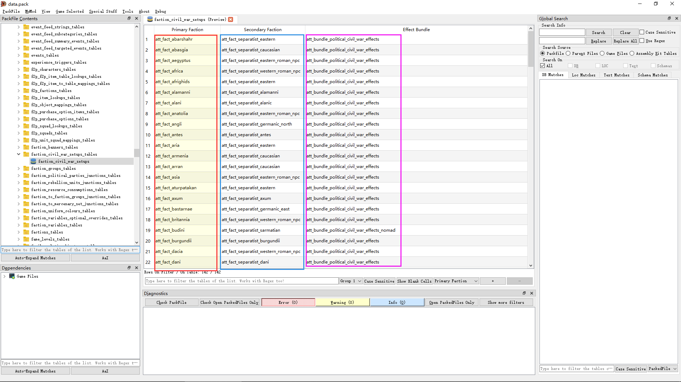

Copy to sheet1

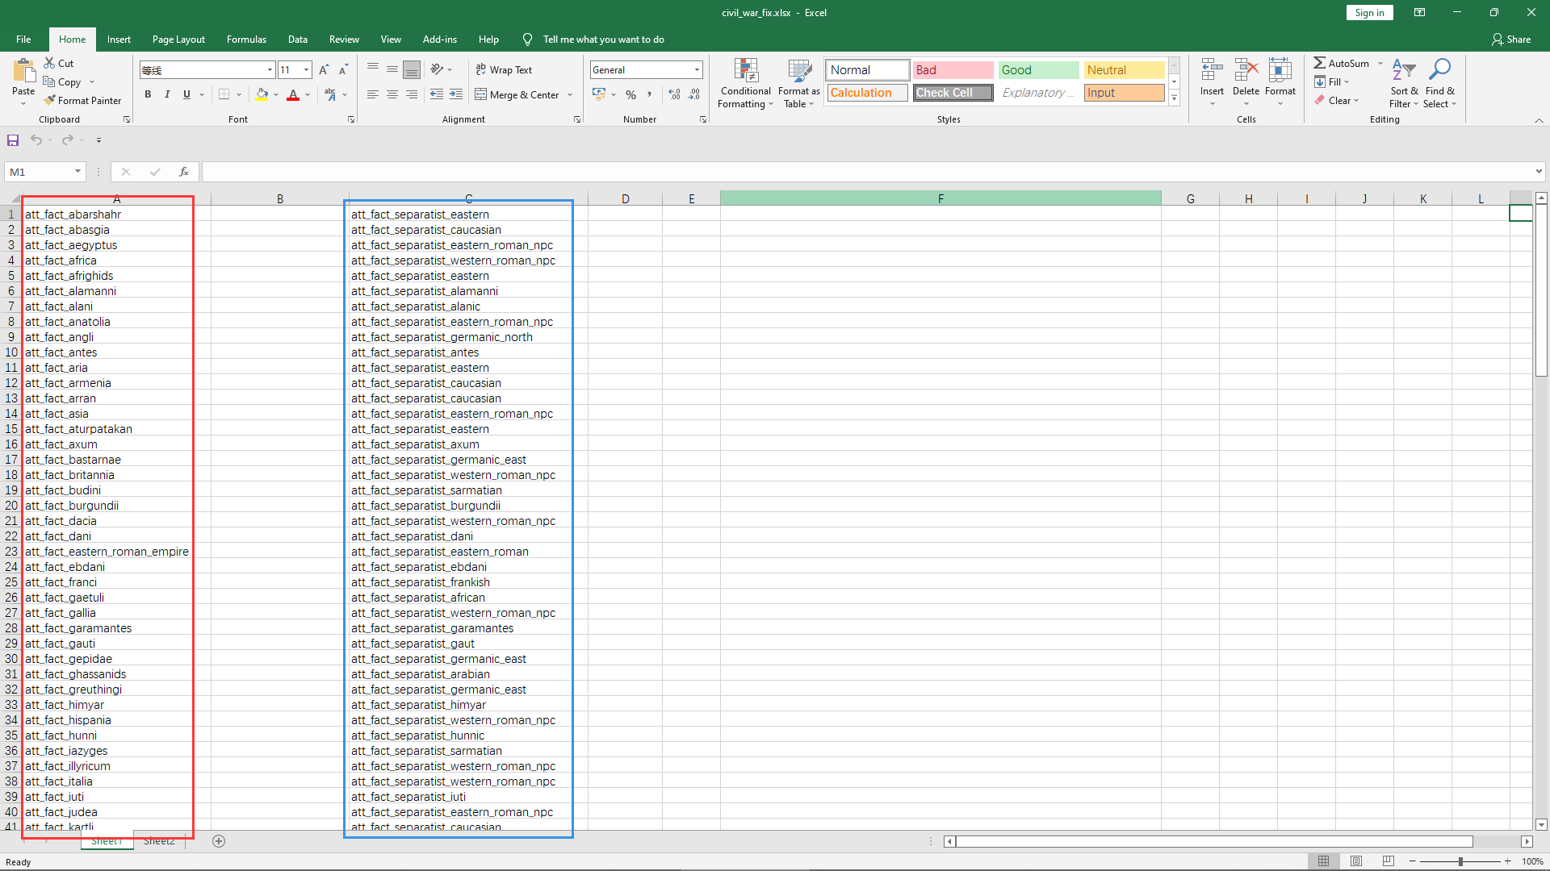

And sheet2

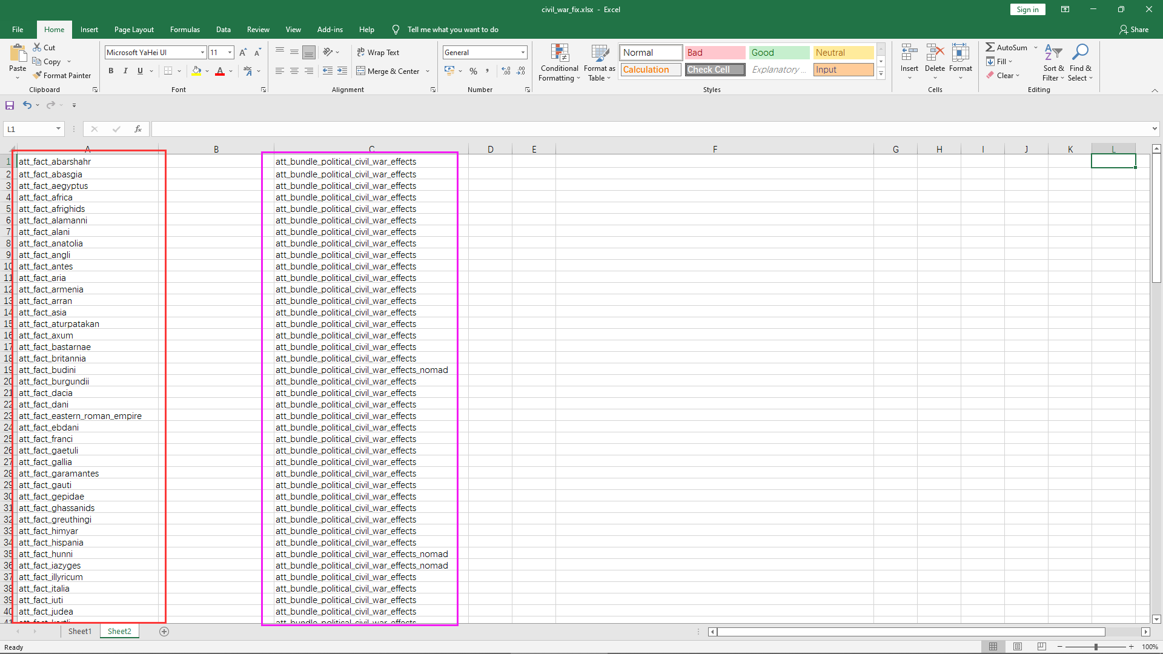

2) Using Excel functions ‘&’ to generate strings as follows:

Sheet1

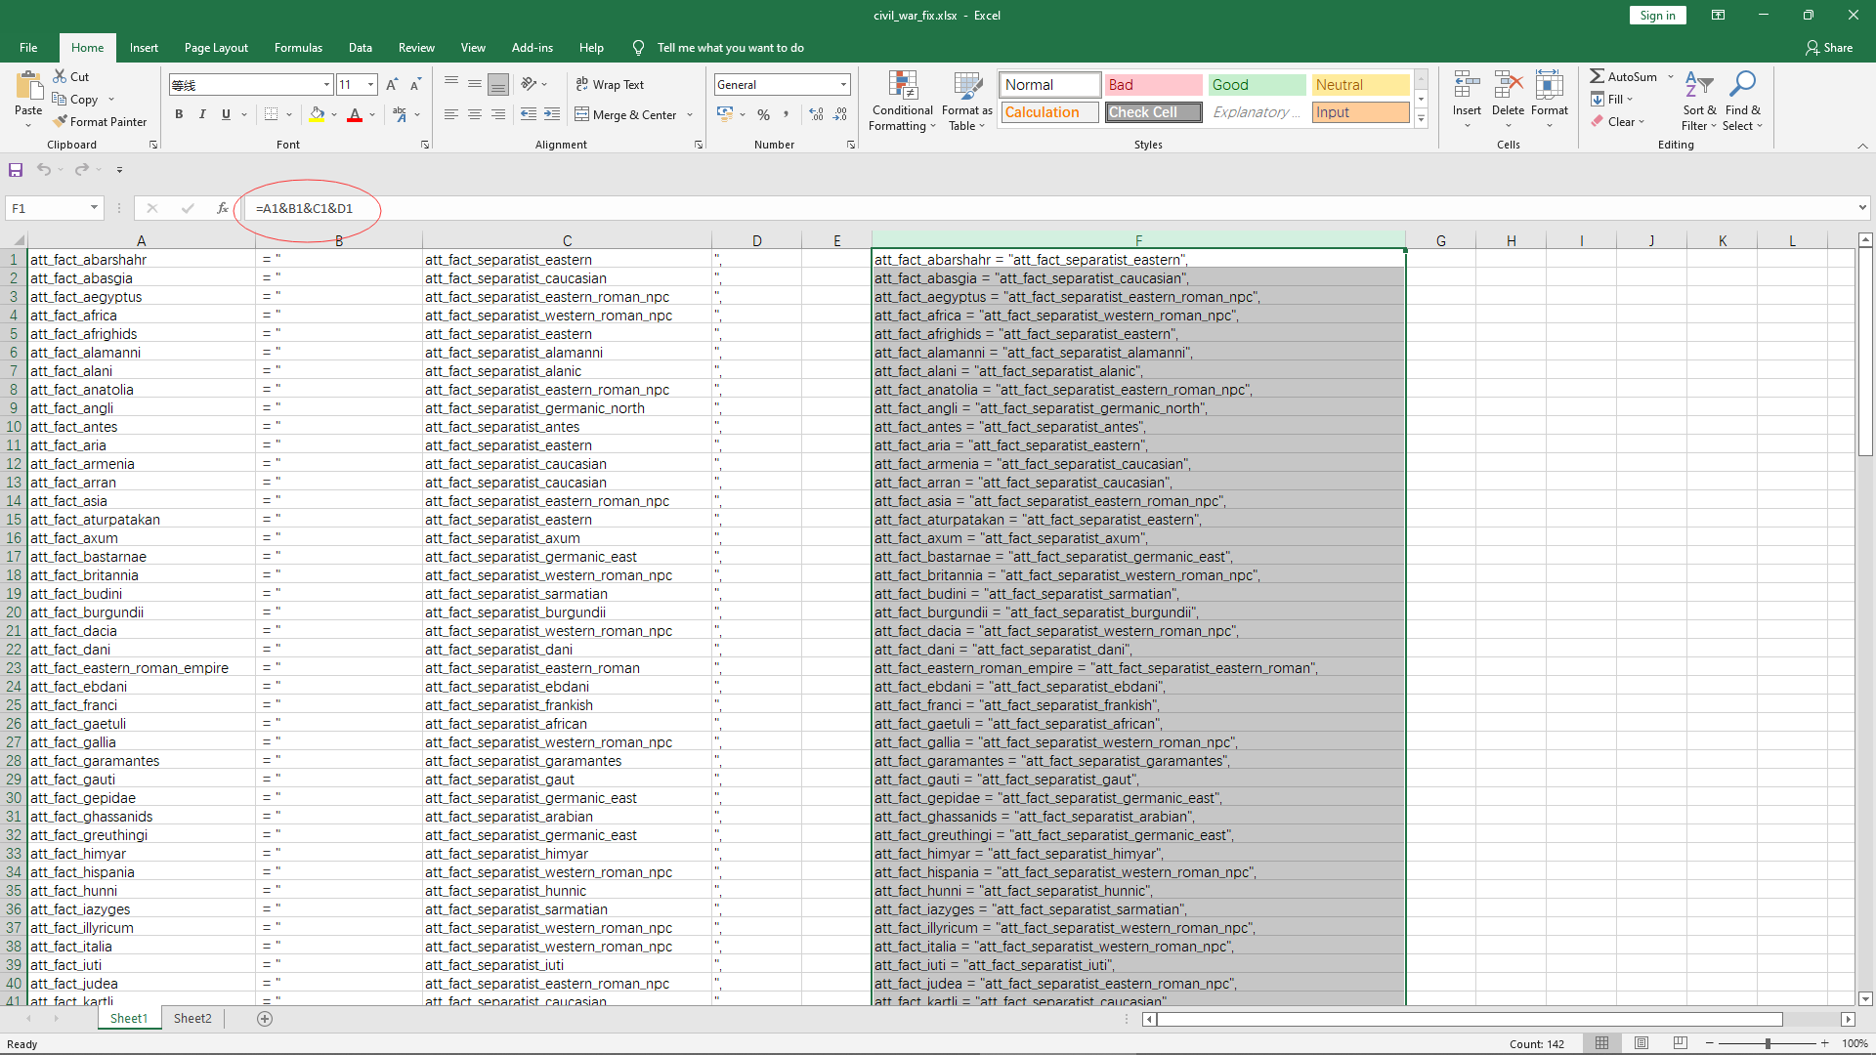

Sheet2

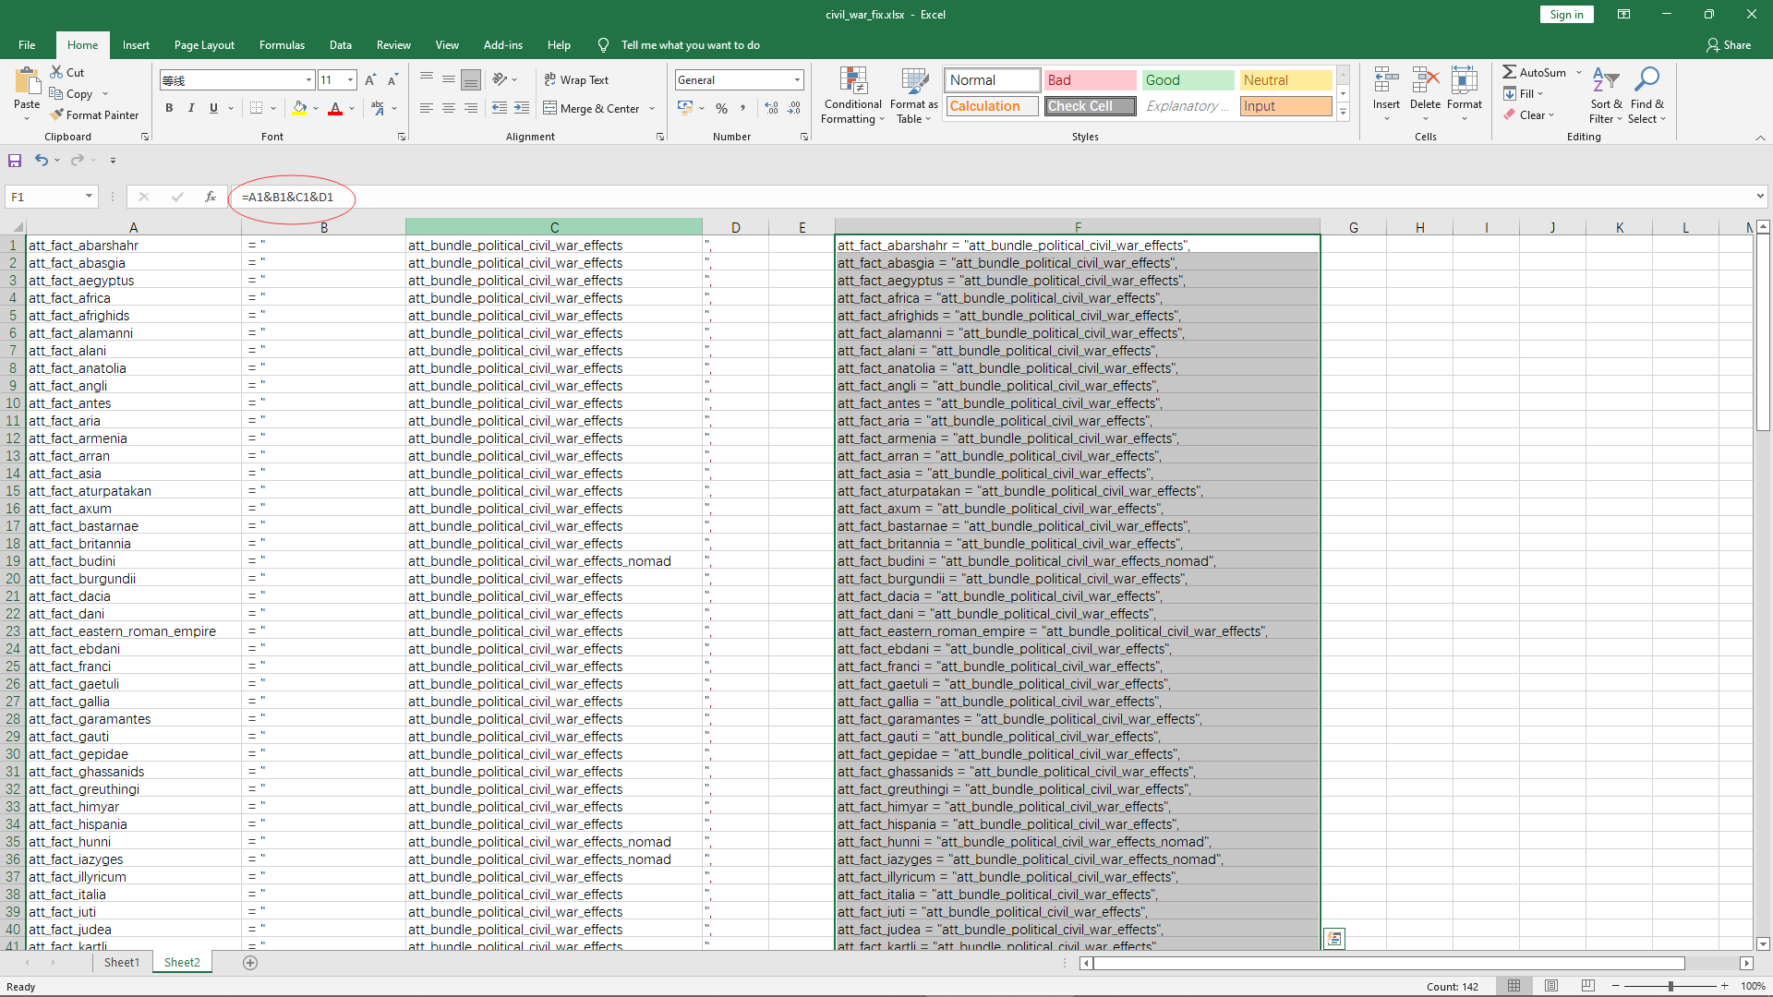

3) Copy column F in sheet1 and sheet2 into FACTION_SEPARATSIT array and CIVIL_EFFECT array in *civil_war_string.lua* added in step 1.

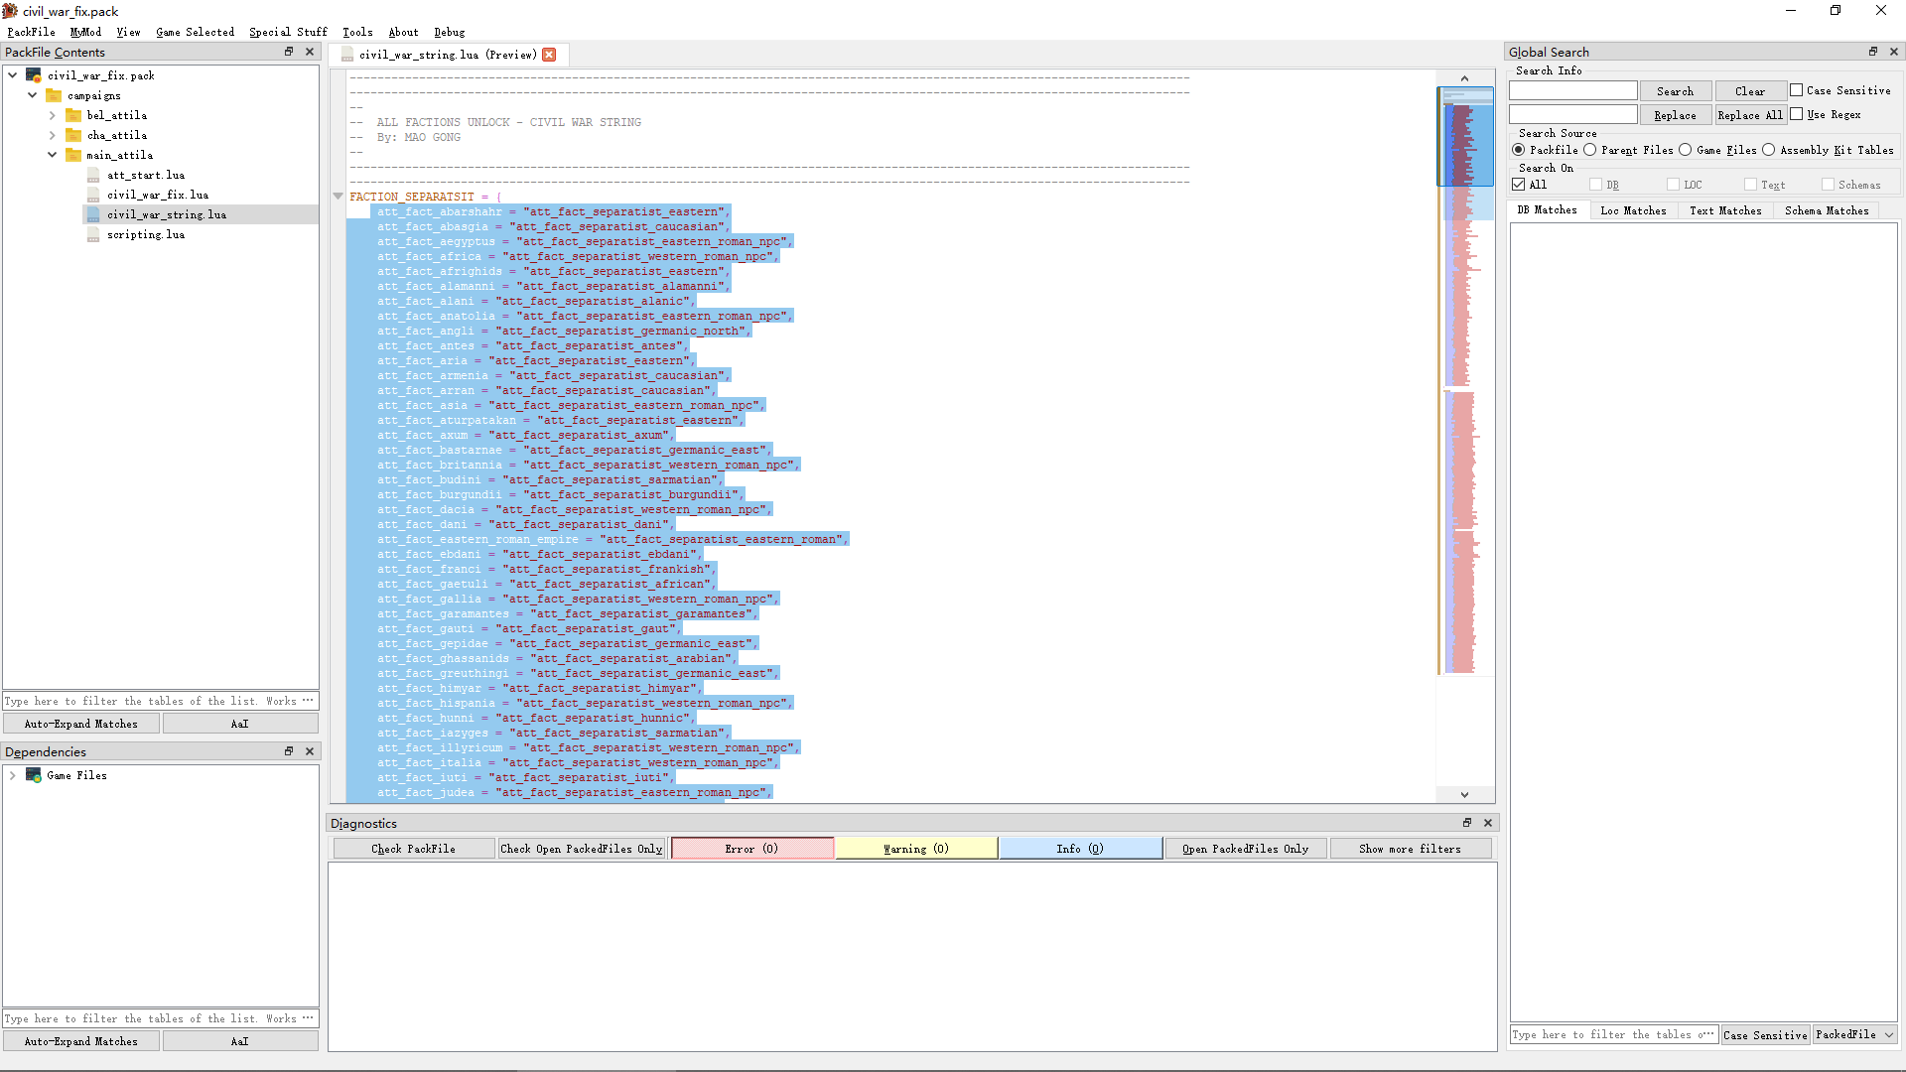

And

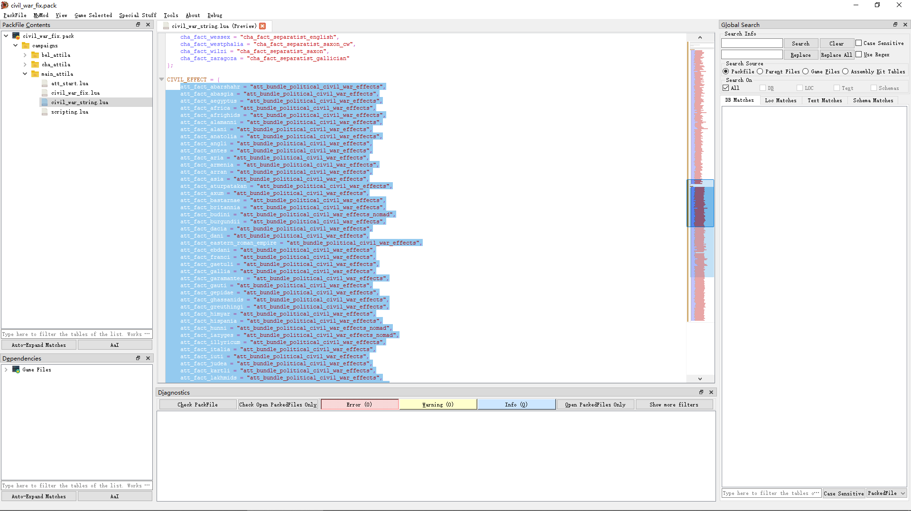

Now the tutorial is finished. You can test whether it works in game.

For further debugging, the *dev.lua* and *util.lua* can be added from *1212_script.pack/lua_scripts*.

Good Luck!